**Structure**

<https://github.com/seothemes/genesis-starter-theme>

<https://wpsites.net/genesis-hooks/>

your-theme-name/ # → Root directory

├── admin/ # → load admin functions

├── assets/ # → Front-end assets

│ ├── css/ # → css

│ ├── fonts/ # → font

│ ├── images/ # → images

│ ├── js/ # → java scripts

│ └── externalframework/ # → load external css or script frameworks

│ └── bootstrap.css # → theme options functions

│ └── bootstrap.js # → theme options functions

├── helperclasses/ # → common class

│ └── htmlhelper.php # → helper functions for dynamic html tags

│ └── phphelper.php # → helper functions for php functions

├── core/ # → register all support items

│ └── customtypes-register.php # → register custom type

│ └── thememeta-register.php # → register meta boxes

**├── includes/ # → common class**

**│ └── themeoptions.php # → theme options functions**

├── config/ # → Config directory

├── lib/ # → Theme functions

│ ├── functions/ # → General functions

│ ├── plugins/ # → Plugin functions

│ ├── shortcodes/ # → Shortcode functions

│ ├── structure/ # → Structural functions

│ └── init.php # → File autoloader

├── templates/ # → Page templates

│ ├── header/ # → different header layouts

│ ├── footer/ # → different footer layouts

│ ├── navigation/ # → different navigation layouts

│ ├── page/ # → different page payouts

│ ├── post/ # → different post layouts

│ └── others/ # → different post layouts

│ └── contact.php # → theme options functions

│ └── about-us.php # → theme options functions

├── partials/ # → Page templates

│ ├── content.php # → custom page type partially load

│ ├── content-single.php # → custom page type single partially load

~~├── tests/ # → PHP Unit tests~~

~~├── vendor/ # → Composer packages~~

~~├── node_modules/ # → Node.js packages~~

├── composer.json # → Composer settings

├── package.json # → Node dependencies

~~├── webpack.mix.js # → Laravel mix config~~

├── screenshot.png # → Theme screenshot

**├── functions.php # → Loads init files**

**├── style.css # → Blank stylesheet**├

**├── index.php # → default fallback file**

**├── header.php # → default header**

**├── footer.php # → default footer**

├── front-page.php # → **home page design**

**├── page.php # → default template for page (posttype-> page)**

├── page-sidebar.php # → sidebar design for page

├── page-customposttype-template.php # → design template for custom post

├── search.php # → for search

├── searchform.php # → for search form design

├── sidebar.php # → common sidebar design for page or post

**├── single.php # → single page for default post (posttype-> post)**

**├── single-customposttype.php # → single page for custom post type**

**├── functions-loader.php # → use instead of functions.php**

├

├── archive.php # → for comments

├── comments.php # → for comments

└── rtl.css # → stylesheet for right to left alignment

Expression:

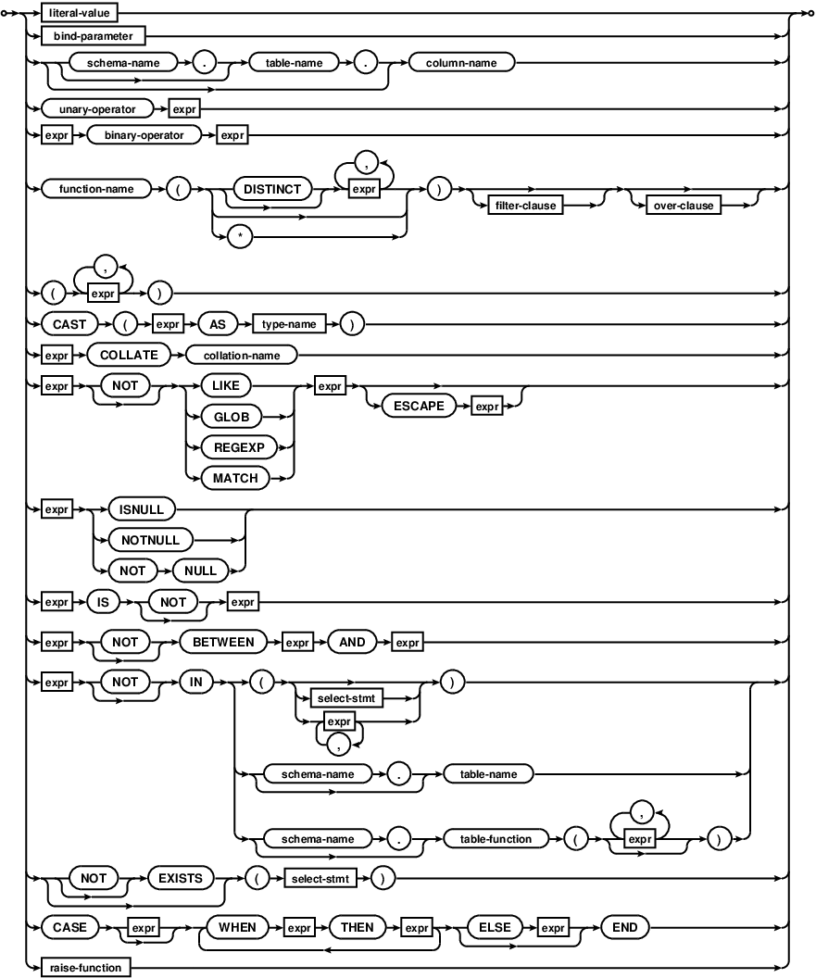

|  |  |
| --- | --- |
| [**filter-clause:**](https://www.sqlite.org/draft/syntax/filter-clause.html) |  |
| [**literal-value:**](https://www.sqlite.org/draft/syntax/literal-value.html) | **C:\Users\SD027\AppData\Local\Microsoft\Windows\INetCache\Content.Word\literal-value.gif** |
| [**over-clause:**](https://www.sqlite.org/draft/syntax/over-clause.html) |  |
| [**raise-function:**](https://www.sqlite.org/draft/syntax/raise-function.html) |  |
| [**select-stmt:**](https://www.sqlite.org/draft/syntax/select-stmt.html) |  |
| [**common-table-expression:**](https://www.sqlite.org/draft/syntax/common-table-expression.html) |  |
| [**compound-operator:**](https://www.sqlite.org/draft/syntax/compound-operator.html) |  |
| [**join-clause:**](https://www.sqlite.org/draft/syntax/join-clause.html) |  |
| [**ordering-term:**](https://www.sqlite.org/draft/syntax/ordering-term.html) |  |
| [**result-column:**](https://www.sqlite.org/draft/syntax/result-column.html) |  |
| [**table-or-subquery:**](https://www.sqlite.org/draft/syntax/table-or-subquery.html) |  |
| [**window-defn:**](https://www.sqlite.org/draft/syntax/window-defn.html) |  |
| [**type-name:**](https://www.sqlite.org/draft/syntax/type-name.html) | **C:\Users\SD027\AppData\Local\Microsoft\Windows\INetCache\Content.Word\type-name.gif** |

[**select-stmt:**](https://www.sqlite.org/draft/syntax/select-stmt.html)

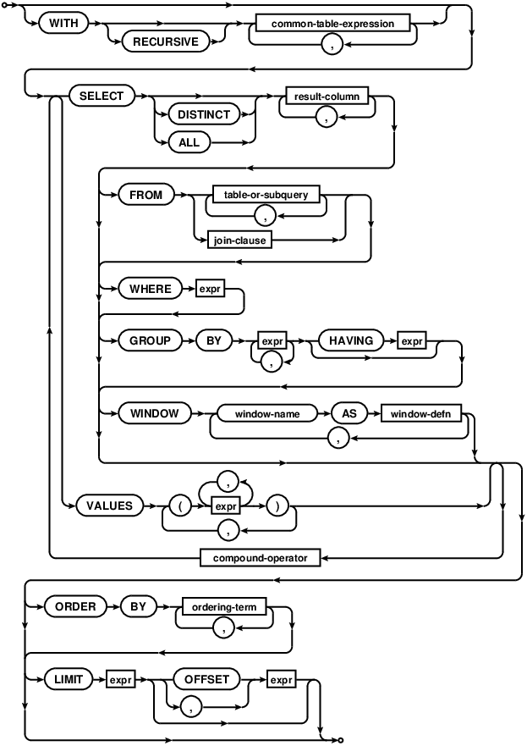

[**table-or-subquery:**](https://www.sqlite.org/draft/syntax/table-or-subquery.html)

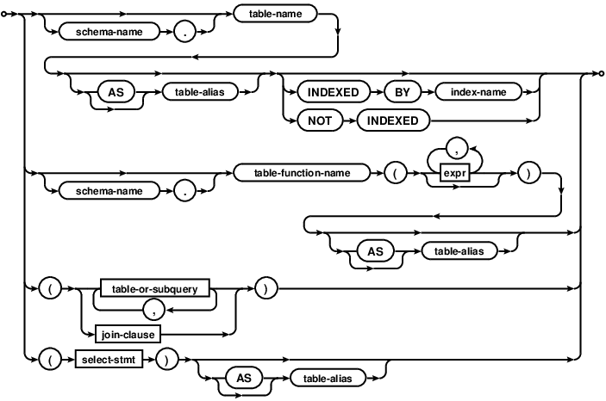

<https://scotty-t.com/2012/01/30/understanding-mysql-in-wordpress/>

**WP Query**

<?php

// line 2570 of query.php

// WP_Query->get_posts

$where = apply_filters_ref_array( 'posts_where_paged', array( $where, &$this ) );

$groupby = apply_filters_ref_array( 'posts_groupby', array( $groupby, &$this ) );

$join = apply_filters_ref_array( 'posts_join_paged', array( $join, &$this ) );

$orderby = apply_filters_ref_array( 'posts_orderby', array( $orderby, &$this ) );

$distinct = apply_filters_ref_array( 'posts_distinct', array( $distinct, &$this ) );

$limits = apply_filters_ref_array( 'post_limits', array( $limits, &$this ) );

$fields = apply_filters_ref_array( 'posts_fields', array( $fields, &$this ) );

// line 2589

// for cache plugins, but wide open for everyone

$where = apply_filters_ref_array( 'posts_where_request', array( $where, &$this ) );

$groupby = apply_filters_ref_array( 'posts_groupby_request', array( $groupby, &$this ) );

$join = apply_filters_ref_array( 'posts_join_request', array( $join, &$this ) );

$orderby = apply_filters_ref_array( 'posts_orderby_request', array( $orderby, &$this ) );

$distinct = apply_filters_ref_array( 'posts_distinct_request', array( $distinct, &$this ) );

$fields = apply_filters_ref_array( 'posts_fields_request', array( $fields, &$this ) );

$limits = apply_filters_ref_array( 'post_limits_request', array( $limits, &$this ) );

// line 2614

// screw it, lets filter the resulting string of SQL

$this->request = apply_filters_ref_array('posts_request', array( $this->request, &$this ) );

?>

<https://code.tutsplus.com/tutorials/create-a-settings-page-for-your-wordpress-theme--wp-20091>

**Hooking the Settings Page to WordPress**

function setup_theme_admin_menus() {

// We will write the function contents very soon.

}

// This tells WordPress to call the function named "setup_theme_admin_menus"

// when it's time to create the menu pages.

add_action("admin_menu", "setup_theme_admin_menus");

add_submenu_page($parent_slug, $page_title, $menu_title, $capability, $menu_slug, $function)

$parent_slug is a unique identifier for the top menu page to which this submenu is added as a child.

$page_title is the title of the page to be added

$menu_title is the title shown in the menu (often a shorter version of $page_title

$capability is the minimum capability required from a user in order to have access to this menu.

$menu_slug is a unique identifier for the menu being created

$function is the name of a function that is called to handle (and render) this menu page

If you choose to add the menu page as a submenu to one of the WordPress groups, you can use the following values as the $parent_slug parameter:

Dashboard: index.php

Posts: edit.php

Media: upload.php

Links: link-manager.php

Pages: edit.php?post_type=page

Comments: edit-comments.php

Appearance: themes.php

Plugins: plugins.php

Users: users.php

Tools: tools.php

Settings: options-general.php

The Appearance group looks like a good candidate for placing our settings page. Let's try that, and create our first settings page. Here's an updated version of our menu setup function:

function setup_theme_admin_menus() {

add_submenu_page('themes.php',

'Front Page Elements', 'Front Page', 'manage_options',

'front-page-elements', 'theme_front_page_settings');

}

We still need to create the function theme_front_page_settings for this to work. Here it is in its simplest form:

function theme_front_page_settings() {

echo "Hello, world!";

}

<https://wordpress.stackexchange.com/questions/266318/how-to-add-custom-submenu-links-in-wp-admin-menus>

